

**This is a proposed policy under consultation. Any comments should be sent to the Executive Principal, or the Chair of the Trustees Council by 11th January 2019, at The Priory Learning Trust, Queensway, Weston-super-Mare, BS22 6BP, or by e-mail to** [**tricia.brabham@theplt.org.uk**](mailto:tricia.brabham@theplt.org.uk) **(clerk to the Trustees).**

**School Admission Arrangements for Schools within**

**The Priory Learning Trust**

**2020-21**

# **Contents**

1. Introduction
2. Oversubscription criteria and published admissions number
3. Starting at a primary, infant, junior or secondary school
   1. Applying
   2. Deadline
4. In year school transfer applications
   1. Applications
   2. Outcome
   3. Alternative places
   4. Waiting list
   5. UK Service Personnel and Crown Servants
   6. Fair access
5. General information
   1. Who can apply
   2. Parent
   3. Home address
   4. Change of address
   5. Documentary evidence
   6. Supporting documents
   7. Withdrawal of an offer
   8. Children in care
   9. Brothers and sisters
   10. Distances
   11. Admissions of children outside their normal chronological age group (delayed or accelerated entry)
   12. Deferred entry
   13. Appeals
   14. Statement of Special Educational Needs or Education, Health and Care Plan
   15. Alteration
6. Contact Details
7. First Geographical Area
8. Supplementary Information Form

# 1. **Introduction**

The Priory Learning Trust is a Multi-Academy Trust of primary and secondary schools.

The Priory Learning Trust grew from a passion to bring the power of partnership and sharing to bear and provide a first-class education to a wide range of children, of all abilities and social class groupings, in WSM and especially in North Worle.

We believe that this approach will create happy, confident, and high-achieving students. This truly collaborative approach will also develop great staff relationships and improve staff wellbeing. It promotes healthy competition.

The Priory Learning Trust will:

* Support the aspirations of young people and their ambitions for their future success.
* Contribute to producing aspirational, well-rounded, confident and active citizens.
* Offer a broad range of qualifications.
* Be inspirational learning centres offering exceptional education.
* Combine, share and utilise the highest academic standards and levels of expertise across our academies and partners to design and develop an innovative and inspiring curriculum – learning is at the centre of what we do
* Provide a strong duty of care to nurture and support students' wellbeing and self-esteem.
* Maintain the unique nature of all of the schools within the Trust.
* Give Academy Councils the freedoms to focus on the challenge and support for the improvements in teaching, learning and the curriculum.

The King Alfred School an Academy, Highbridge, Somerset, is also part of The Priory Learning Trust, however their admissions arrangements are a separate policy which is linked to Somerset Council.

In accordance with the School's Academy status, the school is the Admissions Authority.

The arrangements comply with the requirements of the 2014 [School Admissions Code](https://assets.publishing.service.gov.uk/government/uploads/system/uploads/attachment_data/file/389388/School_Admissions_Code_2014_-_19_Dec.pdf) and the 2012 [School Admission Appeals Code](https://assets.publishing.service.gov.uk/government/uploads/system/uploads/attachment_data/file/275897/school_admission_appeals_code_1_february_2012.pdf) issued, issued under Section 84 of the School Standards and Framework Act 1998.

# 2. **Oversubscription criteria and published admissions number**

|  |  |  |  |
| --- | --- | --- | --- |
| **School** | **Age range** | **Year of intake** | **Admissions number** |
| Castle Batch Primary School Academy | 4-11 | Reception | 60 |
| Priory Community School – An Academy | 11-16 | Year 7 | 300 |
| St Anne’s Church Academy | 2-11 | Reception | 60 |
| Worle Community School – An Academy | 11-16 | Year 7 | 300 |

Where a school is named in a child’s Statement of Special Educational Needs or Education, Health and Care Plan, the Admission Authority for the school is legally required to admit the child to the school. Such children will therefore be allocated places at the named school before the oversubscription criteria is applied.

If a school receives more applications than the admission number, the oversubscription criteria will be used to determine who will be allocated places. All applications will be ranked in accordance with the criteria given in order of priority.

# **Castle Batch Primary School Academy**

1. Children in Care at the time of application and children who were previously in Care but ceased to be so because they were adopted (or became subject to a child arrangements order or special guardianship order) immediately following having been in Care.
2. Children of Castle Batch Primary School Academy staff employed on a permanent contract by the school for at least two years at the time of application, or where the member of Castle Batch Primary School Academy staff has been recruited to fill a post for which there is a demonstrable skill shortage. This does not include staff who work on the school campus for other employers
3. Children with a brother or sister who will be attending the school at the time of admission.
4. Children living nearest to the school.

Within each criterion, priority will be given to children living closest to the school measured in a direct line.

# **Priory Community School – An Academy**

1. Children in Care at the time of application and children who were previously in Care but ceased to be so because they were adopted (or became subject to a child arrangements order or special guardianship order) immediately following having been in Care
2. Children of The Priory Learning Trust staff and whose home school is Priory Community School, employed on a permanent contract by the Trust for at least two years at the time of application, or where the member of staff has been recruited to fill a post for which there is a demonstrable skill shortage. This does not include staff who work on the school site for other employers
3. Children living in Priory Community School’s First Geographical Area with a brother or sister who will be attending Priory Community School
4. Children living in Priory Community School’s First Geographical Area and who attend one of the following feeder schools: Castle Batch Primary School Academy and St Anne’s Church Academy.
5. Children living in Priory Community School’s First Geographical Area living closest to the school
6. Children living outside Priory Community School’s First Geographical Area with a brother or sister who will be attending Priory Community School
7. Children living outside Priory Community School’s First Geographical Area and who attend one of the following feeder schools: Castle Batch Primary and St Anne’s Church Academy
8. Children living outside Priory Community Schools’ First Geographical Area living closest to the school

Within each criterion, priority will be given to children living closest to the school measured in a direct line.

Priory Community School’s First Geographical Area is shown in the map at the end of this policy.

A First Geographical Area is an area of priority for a school. Living in this area does not guarantee a child a place at the school but they may receive priority over children who live outside the First Geographical Area.

# **St Anne’s Church Academy**

1. Children in Care at the time of application and children who were previously in Care but ceased to be so because they were adopted (or became subject to a child arrangements order or special guardianship order) immediately following having been in Care
2. Children of St Anne’s Church Academy staff employed on a permanent contract by the school for at least two years at the time of application, or where the member of St Anne’s Academy staff has been recruited to fill a post for which there is a demonstrable skill shortage. This does not include staff who work on the school campus for other employers
3. Children with a brother or sister who was attending the school prior to 1st September 2017 attending the school at time of admission
4. Children living within the first geographical area and have a brother or sister attending the school at time of admission
5. Children living within the first geographical area who attend church or a service at a place of Christian worship with a family member, or children of a parent(s) who attend a church or a service at a place of Christian worship. Defined as attending a church or a service each month for a consecutive period of six months prior to application and evidenced by a signed Supplementary Information Form
6. Children living within the first geographical area
7. Children living outside the first geographical area and have a brother or sister attending the school at time of admission
8. Children living outside the first geographical area who attend church or a service at a place of Christian worship with a family member, or children of a parent(s) who attend a church or a service at a place of Christian worship. Defined as attending a church or a service each month for a consecutive period of six months prior to application and evidenced by a signed Supplementary Information Form (see below)
9. Children living outside the geographical area.

In applying criteria iv, v and vi, allocations will be equally split within the first geographical area between Area A and Area B. In the event of there being an odd number of places available that cannot be equally split, the ranking of applications will be made by drawing lots.

Within each criterion, priority will be given to children living closest to the school measured in a direct line.

St Anne’s Church Academy’s First Geographical Area is shown in the map at the end of this policy.

A First Geographical Area is an area of priority for a school. Living in this area does not guarantee a child a place at the school but they may receive priority over children who live outside the First Geographical Area.

Attendance at a Church or place of Christian worship must be each month for a consecutive period of six months prior to application. Applicants must complete the governors Supplementary Information Form and ensure that the vicar, priest, minister, pastor or warden of their church also completes the relevant sections.

**Admission to St Anne’s Church Academy is to the school only and not to any particular site.** As part of this, a separate site allocation process needs to be completed. Parents are asked to complete a Supplementary Information Form to state which of the St Anne’s sites they wish their child to attend.

Site allocation will be decided by using the school’s allocation list. The allocation list is a list of all children who have been successful at gaining a place at St Anne’s Primary, and will, for reception intake, contain around 60 children’s names that ranked in accordance with the school’s oversubscription criteria. Each ranked child will be considered for site allocation.

West Wick site has a capacity of 30 children per intake.

Hewish site has a capacity of 30 children per intake.

The following criteria will be used to determine the site allocation:

1. Children with a Statement of Special Educational Needs (SEN) or Education Health and Care Plan EHCP with St Anne’s C of E Primary School named as the most appropriate school
2. Children in Care at the time of application and children who were previously in Care but ceased to be so because they were adopted (or became subject to a child arrangements order or special guardianship order) immediately following having been in Care
3. Children with a brother or sister attending a site and a satisfactory Supplementary Information Form has been received.
4. Direct line distance measured from the child’s home to the nearest school site and a satisfactory Supplementary Information Form has been received.
5. Children with a brother or sister attending a site and a satisfactory Supplementary Information Form has NOT been received.
6. Direct line distance measured from the child’s home to the nearest school site and a satisfactory Supplementary Information Form has NOT been received.

If an applicant submits a Supplementary Information Form and their preferred site is already full, the child will still be offered a place at St Anne’s Primary School however it will be at a different site to their preference.

Parents should complete the Supplementary Information Form to state which of the St Anne’s sites they wish their child to attend. The school will determine site allocation and take parental preferences into account where possible.

# **Worle Community School – An Academy**

1. Children in Care at the time of application and children who were previously in Care but ceased to be so because they were adopted (or became subject to a child arrangements order or special guardianship order) immediately following having been in Care
2. Children of The Priory Learning Trust staff and whose home school is Worle Community School, employed on a permanent contract by the Trust for at least two years at the time of application, or where the member of staff has been recruited to fill a post for which there is a demonstrable skill shortage. This does not include staff who work on the school site for other employers
3. Children living in Worle Community School’s First Geographical Area with a brother or sister who will be attending Worle Community School
4. Children living in Worle Community School’s First Geographical Area and who attend one of the following feeder schools: Castle Batch Primary School Academy and St Anne’s Church Academy.
5. Children living in Worle Community School’s First Geographical Area living closest to the school
6. Children living outside Worle Community School’s First Geographical Area with a brother or sister who will be attending Worle Community School
7. Children living outside Worle Community School’s First Geographical Area and who attend one of the following feeder schools: Castle Batch Primary and St Anne’s Church Academy
8. Children living outside Worle Community Schools’ First Geographical Area living closest to the school

Within each criterion, priority will be given to children living closest to the school measured in a direct line.

Worle Community School’s First Geographical Area is shown in the map at the end of this policy.

A First Geographical Area is an area of priority for a school. Living in this area does not guarantee a child a place at the school but they may receive priority over children who live outside the First Geographical Area.

# **3. Starting at a primary, infant, junior or secondary school**

The following information should be read in conjunction with the 2020-21 Coordinated Admission Scheme published by the Local Authority in the area which the child lives (the home Local Authority).

The scheme can be viewed on the North Somerset Council’s website at [www.n-somerset.gov.uk/schoolpublications](http://www.n-somerset.gov.uk/schoolpublications)

# 3.1 **Applying**

North Somerset residents seeking school places should apply on a North Somerset application form. Residents outside North Somerset seeking places at North Somerset schools should apply for places on their home Local Authorities’ application form.

For North Somerset children the application form is available for submission using the online system on the North Somerset Council website or in a paper form. Applicants are strongly advised to read the parent guide for this intake which is available on North Somerset Council’s web site. See contact details section for details.

# 3.2 **Deadline**

Applications must be received by:

* Primary, Infant and Junior schools: 15 January 2020
* Secondary schools: 31 October 2019

Otherwise the application will be recorded as late. Late applications will not be considered in the first round of allocations and an outcome will not be sent on the National Offer Day. Please see North Somerset Council’s [co-ordinated scheme](http://www.n-somerset.gov.uk/my-services/schools-learning/admissions/arrangements-policies-consultations/schoolpublications/) for this intake for full details.

# 4. **In year school transfer applications**

The following applications will be treated as in-year admissions during 2020/21:

* applications for admission to Reception or Year 7 which are received after 1 September 2020
* all other applications for admission to Years 1 to 6 and 8 to 11.

# 4.1 **Applications**

Except for deferred entry for Reception Year Group children, applications will not normally be considered in advance of the date the place is required, this will be approximately 35 days for those moving house, and 21 days for those not moving house. However, applications for admission in September 2020 can be made from 1 June 2020.

# 4.2 **Outcome**

Any offers must be responded to within 21 days of the date of the letter. Any request for an extension beyond the required reply date will be considered on an individual basis.

# 4.3 **Alternative places**

The Admissions Authority is required to notify North Somerset Council of any in year transfer applications received and the outcome of them. If a place is unable to be offered at a preferred school and the applicant is, or has proven they will be, a resident of North Somerset then the Council will either:

1. offer a place at the nearest school to the home address with a place available
2. advise the applicant of places that may be available at Own Admission Authority school(s)
3. if the child is currently attending the nearest available school to the home address, the Council is not required to take any actions.

The nearest school to the child’s home address with a place available will be identified by using the shortest available walking route.

Where there are more children than places available at the intended offer school, the schools’ oversubscription criteria will be used to determine who can be offered.

The alternative school offered may not be the nearest one available, if after having had regard to any reasons expressed by the parent for their (unsuccessful) preferences and a schools’ admission arrangements, North Somerset Council felt it was appropriate to offer a different alternative school.

# 4.4 **Waiting list**

Where there are more children than places available, a waiting list will operate for each year group. If parents would like their child’s name to be added to the waiting list they must request it, as no child is added automatically.

The waiting list will be maintained on a two term basis. If applicants wish to remain on the waiting list they must request this for the start of terms 1, 3 or 5. Any applicants that have not requested to be kept on the waiting list will not be considered for any vacancies that may arise. Term dates can be found at [www.n-somerset.gov.uk/school-term-dates](http://www.n-somerset.gov.uk/school-term-dates).

Any application or appeal that is yet to be processed will be considered for a vacancy along with those already on the waiting list. When filling a vacancy, all those seeking a place at the time the decision is made (not at the time the vacancy occurs) will be considered.

Children who are the subject of a direction by a Council to admit or those who are allocated a school in accordance with the Fair Access Protocol, will take precedence over those on the waiting list.

Priority will not be given on the basis of the date an application was added to the list. All applications must be ranked in line with the admission authority’s [oversubscription criteria](http://www.n-somerset.gov.uk/my-services/schools-learning/admissions/arrangements-policies-consultations/schoolpublications/) and any allocations will be made using this. Each child added to a waiting list will require the list to be ranked again in line with the published oversubscription criteria. Waiting list positions can go up as well as down as additional applicants are added to or removed from the waiting list and ranked in accordance with the specific oversubscription criteria.

# 4.5 **UK Service Personnel and Crown Servants**

For UK Service Personnel and other Crown Servants, where possible, places may be allocated in advance of the pupils return to the UK provided the MOD, FCO or GCHQ have provided a letter declaring a return date and residency placement. Places may be offered and reserved up to one term in advance of the place being required. North Somerset operates 6 terms per year. Term dates can be found at [www.n-somerset.gov.uk/school-term-dates](http://www.n-somerset.gov.uk/school-term-dates)

# 4.6 **Fair access**

Each Local Authority **must** have a Fair Access Protocol, agreed with the majority of schools in its area to ensure that - outside the normal admissions round - unplaced children, especially the most vulnerable, are offered a place at a suitable school as quickly as possible. In agreeing a protocol, the Local Authority **must** ensure that no school - including those with available places – is asked to take a disproportionate number of children who have been excluded from other schools, or who have challenging behaviour. The protocol **must** include how the Local Authority will use provision to ensure that the needs of pupils who are not ready for mainstream schooling are met.

The Fair Access Protocol is available at [www.n-somerset.gov.uk/fair-access-protocol](http://www.n-somerset.gov.uk/fair-access-protocol)

# 5. **General Information**

# 5.1 **Who can apply**

Applications will be accepted for children who meet one or more of the following:

* they are resident in the UK
* they hold full British Citizen Passports
* they are from countries whose passports have been endorsed to show that they have the right to abode in this country
* they are from the European Economic Area (EEA).

Applications for children who do not meet one of the above will not be accepted until the child is in this country.

# 5.2 **Parent**

This includes all of those people, including carers, who have parental responsibility for a child as set out in the Children Act 1989. All references within this document to parent(s) therefore include carers.

# 5.3 **Home address**

A child’s home address is considered to be the place where the child permanently and ordinarily resides for the majority of the time as at the closing date and time. This would normally be the same address as a person who has parental responsibility for the child and is their main carer.

An address used for childcare arrangements cannot be used as the home address. The address of a child that is different from his/her parents where the move to this address is expressly linked to obtaining a school place will not be accepted.

Where parents do not live together, and the child spends equal amounts of time with both parents, the home will be considered to be that of the parent who made the application to be the child’s home.

More than one address will not be accepted as the child’s home address. If necessary, the terms of a residency order may clarify the home address.

If parents share parental responsibility for the child, and both parents submit an application form, both parents will be asked to determine which application should be considered and which application should be withdrawn. If parents are unable to reach an agreement, a Specific Issues Order or a residency order will be requested to be seen for clarification on which address should be used.

In the absence of any Specific Issues or residency order, the home address will be considered to be that of the parent with the primary day to day care and control of the child. In reaching this decision, evidence may be requested from both parents. Examples of evidence would be the address of the parent who receives Child Benefit and/or the address which is registered with a medical GP. Parents are urged to reach agreement but where they do not, the home address will be determined for them.

If a child is temporarily living away from his/her parents in a different Council area, the Council where the child ordinarily lives will continue to be the home Council.

Whilst the place of residence of the child for the first round of allocations would normally be his/her physical place of residence as at Closing Date and time for applications, it should be noted that in certain circumstances and acting in the interests of the child, an alternative place of residence may be used*, for example where a child is temporarily living away from his/her parent’s home and the new temporary place of residence is the home where the child is likely to be living whilst attending school.

*If necessary this would be determined by North Somerset Council.

# 5.4 **Change of Address**

Parents must inform North Somerset Council if they change address as soon as possible or any offer of a place may be withdrawn. If a change of address will occur after the closing time and date (and before the start of term 1), and independent confirmation is submitted by the closing time and date, it will be considered in the first round of allocations.

Examples of independent confirmation of a change of address are:

* a solicitor’s letter confirming the exchange of contracts with a completion date,
* a tenancy agreement signed by both parties,
* a utility bill dated within three months prior to submission.

If the child is from a family of a Crown Servant or of UK Service Personnel, a letter from the MOD, FCO or GCHQ declaring a return date and residency area.

Applicants may also be required to provide proof that they have left the previous property, for example by supplying a final account utility bill.

If a new address is not accepted for a round of allocations, where none of the parental preferences can be offered, the alternative school offered will be based on the new address (providing details and independent confirmation is received before the round of allocation has been finalised).

Where a change of address is from one Local Authority to another, the Local Authority of the new address, will then normally be the home Local Authority. The new home Local Authority will then process the application and notify the parents of the outcome.

# 5.5 **Documentary evidence**

The Admissions Authority reserves the right to require documentary evidence of the genuineness of a family address and if this is not produced, reserves the right to make its own enquiries.

The child’s normal permanent home address where he or she lives with his or her parents or legal guardians will be used to decide where the child lives. If parents or guardians plan to move documentary evidence will be required.

Examples of evidence that may be acceptable to determine a child’s address are:

1. A solicitor’s letter confirming exchange of contracts and a completion date for a property which is being purchased or a property which is being sold.
2. A copy of a signed rental agreement or a solicitor’s letter if moving to a Council or rented property and proof of your sale or Notice to Quit on your current/previous property.
3. A copy of a council tax bill or utility bill such as water, gas or electricity in your name for your newly owned or rented property together with proof of your sale or Notice to Quit on your current/previous property.
4. If you are moving in with a relative a letter from them will be required confirming the date you will be moving in together with a copy utility bill showing their name and address. A solicitor’s letter will also be required confirming that completion of contracts has taken place on your sale or Notice to Quit on your current/previous property.

# 5.6 **Supporting documents**

Any letters/supporting documents should also be submitted to the Admissions Authority. Applications and any letters/supporting documents received by the School Admissions Team at its office in Castlewood, Tickenham Road, Clevedon may also be accepted.

Whilst it is not the responsibility of other offices/schools, the Admissions Authority will use discretion and may accept applications/documents received by other Councils, Schools or other Council offices that are passed to the School Admissions Team. They will be accepted as on time if North Somerset Council feels they may have been submitted by the closing time and date.

# 5.7 **Withdrawal of an offer**

The Admissions Authority reserves the right to withdraw an offer of a school place in certain limited circumstances. Examples include:

1. Where a parent has given fraudulent or intentionally misleading information such as a false address, which effectively denied a place to a child with a stronger claim.
2. Where a parent has not responded to an offer within the deadline set or to any subsequent reminder to reply within a further 7 days.
3. Where the offer was made as a result of an administrative error.
4. If children do not commence attendance at school at the date arranged for their child to commence and the school is not given a satisfactory reason for the absence.

If a child or parent(s) move address but the parents do not inform the Admissions Authority, this may be deemed to be intentionally misleading and any place offered may be withdrawn if it has denied another child a place.

Where before offers are made, an application is deemed to be fraudulent or intentionally misleading the application will be considered on the basis of the correct information. It is the parent’s responsibility to inform North Somerset Council and the Admissions Authority if their contact details change after making an application.

# 5.8 **Children in care**

Children in Care are defined as follows:

Children in Care’ are children who are (a) in the care of a local Council or (b) being provided with accommodation by a local Council in the exercise of their social services functions (see the definition in section 22(1) of the Children Act 1989).

For Children previously in Care:

* this includes children who were adopted under the Adoption Act 1976 (see section 12 adoption orders) and children who were adopted under the Adoption and Children Act 2002 (see section 46 adoption orders)
* child arrangements orders are defined in s.8 if the Children Act 1989, as amended by s.12 of the Children and Families Act 2014. Child arrangements orders replaced residence orders and any residence order in force prior to 22 April 2014 is deemed to be a child arrangements order
* in accordance with Section 14A of the Children Act 1989, a Special Guardianship Order is defined as an order appointing one or more individuals to be a child’s special guardian (or special guardians).

# 5.9 **Brothers and sisters**

To be considered as a brother or sister a child must be living at the same address for the majority of the time (at least 50% of the time), as a full, half, step or adoptive brother/sister.  
  
Full and adoptive brothers/sisters are defined as children who have the same biological or adoptive parents.

Half brothers/sisters are defined as children who share only one biological or adoptive parent.   
  
Step brothers/sisters are defined as children who are not necessarily related biologically (including foster children) but are living in the same household for the majority of the time at the address the Admissions Authority considers to be the address of the child for whom the application is made.

It is the responsibility of parents to ensure that they declare on their application if they have a child (or have been allocated a place for a child) at their preferred school(s) or to inform the Admissions Authority if a child obtains a place after they have applied.  
  
A brother or sister must be attending (or is expected by the Admissions Authority to be attending) the school at the time of admission.

A child attending a nursery/pre-school part of a school does not count as a brother or sister attending the school at the time of admission.

# 5.10 **Distances**

A direct line distance is where distances are measured in a straight line between the address point of the child’s home and the main entrance marker for the school, indicated on North Somerset Council computerised system(s). Unless stated otherwise, where the direct line distances are equal, the ranking of applications will be determined by drawing lots.

If it is not possible to measure a distance on North Somerset Council computerised system(s), North Somerset Council will use alternative methods.

# 5.11 **Admissions of children outside their normal chronological age group (delayed or accelerated entry)**

Admissions of children outside their normal chronological age group (delayed or accelerated entry):

Applications for delayed or accelerated entry in cases where parents would like their child to be admitted to a year group that is not the chronological age year group, will be considered. The admissions authority for the school will make the final decision.

In addition, parents of summer born children (born on or between 1 April and 31 August) can request to admit their child into the Reception year, one year after they would normally enter the school. The admissions authority for the school will make the final decision.

Decisions will be made on the basis of the circumstances of each case and in the best interests of the child. This will include taking account:

* the parent’s views;
* information about the child’s academic, social and emotional development;
* where relevant, their medical history and the views of a medical professional;
* whether they have previously been educated out of their normal age group;
* whether they may naturally have fallen into a lower age group if it were not for being born prematurely.

The admissions authority must also take into account the views of the head teacher.

Parents will need to write to the school to request that their child starts a year later or earlier than their chronological age. Parents will need to give reasons for the request and details of the child’s particular needs. Any reports or evidence to support your request should also be enclosed.

For Reception and Junior intake applications, it is advised that an on time application is submitted for the correct chronological year group. If the delay/accelerated request is agreed, the on time application can be withdrawn and a new application should be made the following year. If the request is not agreed, and the child stays in their chronological age group, the on time application can still be processed. If a request is not agreed and the child does not have an on time application then a late application would need to be submitted.

Where the admission authority agrees to a parent’s request for their child to be admitted out of their normal age group the parent must apply according to the timescales of the agreed admission cohort. The application will be processed as part of the main admissions round (including applying the oversubscription criteria where applicable), unless the parental request is made too late for this to be possible. Parents have a statutory right to appeal against the refusal of a place at a school for which they have applied and been refused. This right does not apply if they are offered a place at the school but it is not in their preferred age group.

Where the admission authority does not agree a request for a summer born child to be admitted into the Reception Year Group, the parent may apply for their child to be admitted with their chronological age group for admission at the time they would normally enter the school. Such children who do not start school in the school year that they become 5 will normally be placed in a Year 1 class and will miss the Reception year.

# 5.12 **Deferred Entry**

Places will be offered for admission in September 2020. However, depending on their child’s date of birth, places may be deferred until the start of [term 3 or 5](http://www.n-somerset.gov.uk/school-term-dates) but no later than the term following the child's fifth birthday and cannot be deferred until the start of the following academic year. Parents should make any request to the school for a deferment once they have received an offer of a school place. The school place will be held for that child and will not be available to be offered to another child.  
  
All children offered a place are entitled to a full-time place in the September following their fourth birthday. Parents can request that their child takes up their place on a part-time basis until their child reaches compulsory school age.

If parents wish to defer their child’s admission and the term following their fifth birthday would be September 2021, parents will need to notify the school, where a place has been offered, of their intentions to do so. Parents will need to put this in writing to the school and their child’s place at the school will be withdrawn and may be offered to another child. It is then the parent’s responsibility to apply for a school place in year 1, with their chronological cohort.

Parents should be aware that a school might become full in the Reception age group with pupils whose parent applies for a place during the 2020-21 school year. There may be no places available in a preferred school for those who defer their child’s admission until Year 1. These parents will need to apply for a Year 1 school place for their child and these applications will be considered from June 2021 onwards.

All children offered a place are entitled to a full time place in the September following their fourth birthday.

Parents may also request that that their child takes up their place part time until the child reaches compulsory school age.

# 5.13 **Appeals**

All applicants refused a place have a right of appeal to an independent appeal panel constituted and operated in accordance with the [School Admission Appeals Code](https://assets.publishing.service.gov.uk/government/uploads/system/uploads/attachment_data/file/275897/school_admission_appeals_code_1_february_2012.pdf).

Details of how to appeal are included in the outcome email or letter.

# 5.14 **Statement of Special Educational Needs or Education, Health and Care Plan**

Applicants in receipt of a Statement of Educational Needs or Education, Health and Care Plan should contact their SEN Officer to apply for schools.

# 5.15 **Alteration**

It should be noted that this policy is subject to alteration to reflect any changes in legislation, case law, Council policy or to ensure legal compliance.

# 6. **Contact Details**

|  |  |
| --- | --- |
|  | Address: Castle Batch Community Primary School  Academy  Rawlins Avenue  Worle  Weston-Super-Mare  BS22 7FN  Tel No: 01934 514552  Email: mailbox@castlebatch.org.uk  Website: www.castlebatch.n-somerset.sch.uk |
|  | Address: Priory Community School – An Academy  Queensway  Weston-super-Mare  BS22 6BP  Tel No: 01934 511411  Email: mailbox@pcsa.org.uk  Website: www.priory.n-somerset.sch.uk |
|  | Address, Hewish site:  St Anne’s Church Academy  Bristol Road  Hewish  Weston-super-Mare  BS24 6RT  Address, West Wick site:  St Anne’s Church Academy  1 Scot Elm Drive  West Wick  Weston-super-Mare  BS24 7JU  Tel No (Hewish): 01934 832159  Tel No (West Wick): 01934 520461  Email: stanne[s.pri@n-somerset.gov.uk](mailto:pri@n-somerset.gov.uk)  Website: [www.stannesprimaryschool.co.uk](http://www.stannesprimaryschool.co.uk) |
|  | Address: Worle Community School – An Academy  Redwing Drive  Weston-super-Mare  BS22 8XX  Tel No: 01934 510777  Email: [admin@worle-school.org.uk](mailto:admin@worle-school.org.uk)  Website: www.worle.n-somerset.sch.uk |
| NSCmonoLOGO | Address: School Admissions Team  People and Communities  North Somerset Council  Town Hall  Walliscote Grove Road  Weston-super-Mare  BS23 1UJ  Tel No: 01275 884078 / 884014  Email: [admissions@n-somerset.gov.uk](mailto:admissions@n-somerset.gov.uk)  Website: [www.n-somerset.gov.uk/admissions](http://www.n-somerset.gov.uk/admissions) |

# 7. **First Geographical Area**

# **Priory Community School – An Academy**

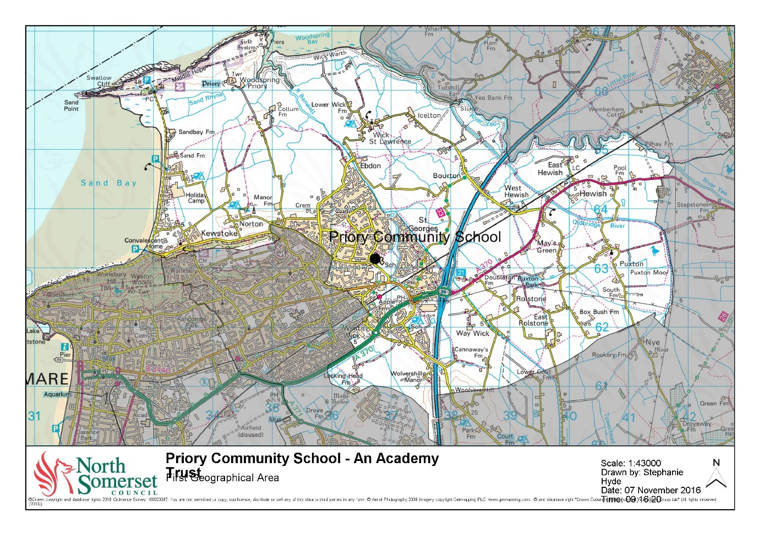

# **St Anne’s Church Academy**

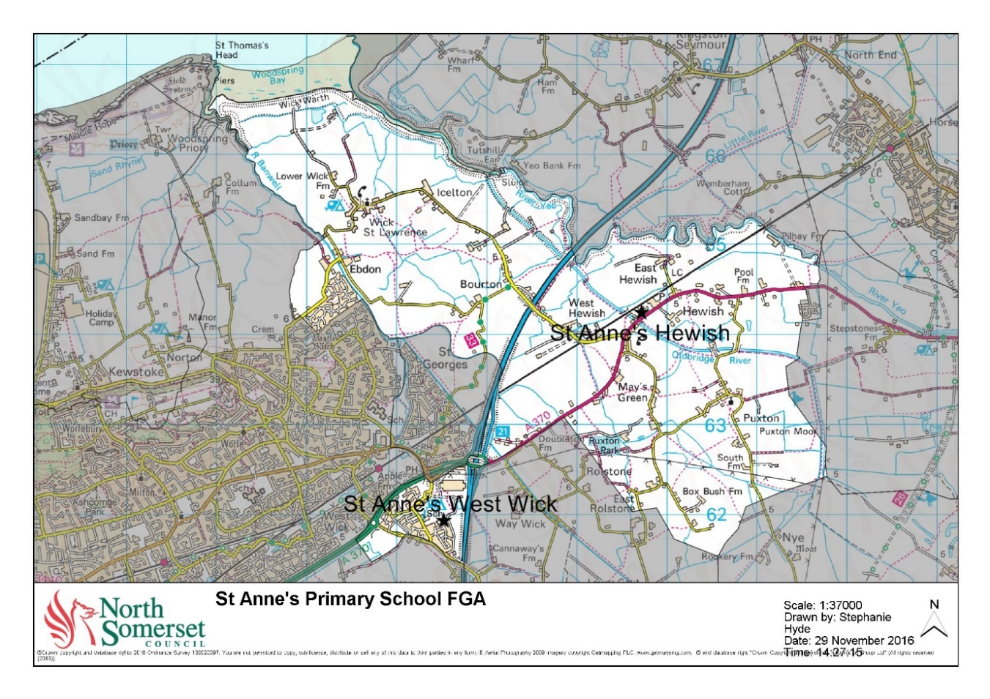

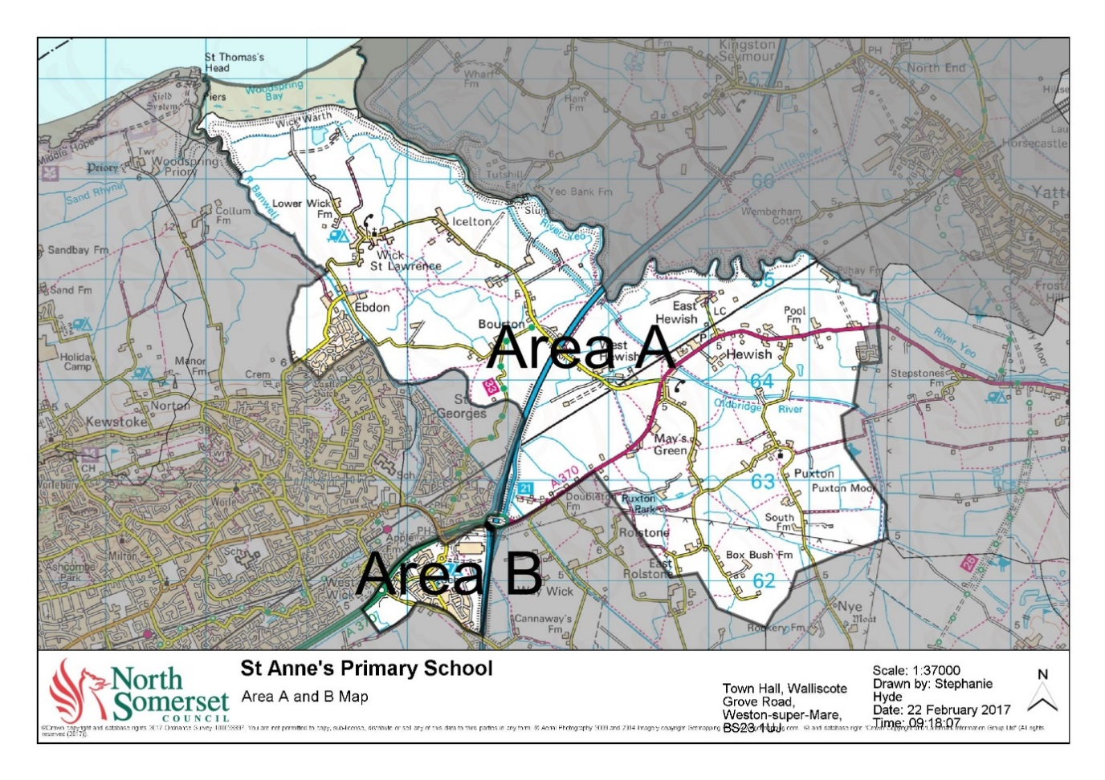

# **Worle Community School – An Academy**

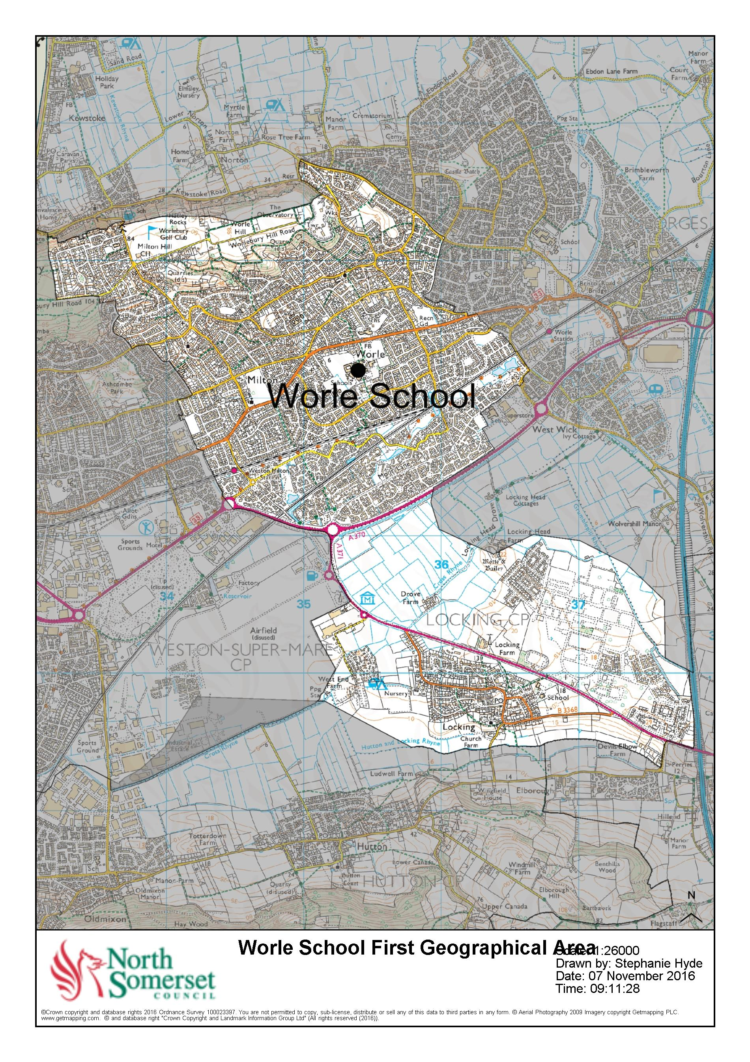



**St Anne’s Church Academy**

# **Supplementary Information Form**

**It is the parent’s responsibility to ensure that the requirements, detailed in this Supplementary Information Form, are fully met prior to submission.**

**Please make sure this is completed and returned to the school by 23:59 on 15 January 2020 to be considered in the first round of allocations.**

The school is designated as a school with a religious character and as such is permitted to give priority to applicants who are of the faith of the school. The purpose of the Supplementary Information Form is to verify the Christian commitment of the parent(s) applying and to identify the preferred site.

**Child’s details**

|  |  |
| --- | --- |
| First name (s) |  |
| Last name |  |

**Parent’s details**

|  |  |
| --- | --- |
| First name (s) |  |
| Last name |  |

|  |  |  |  |
| --- | --- | --- | --- |
| Address |  | | |
|  |  | | |  |
|  |  | Postcode |  |

|  |  |  |
| --- | --- | --- |
| **Preferred site** | | **Please tick** |
| I would prefer to attend the Hewish site | |  |
| I would prefer to attend the West Wick site | |  |
| I have a sibling already attending St Anne’s Church Academy. | |  |
| Sibling first name (s) |  | |
| Sibling last name |  | |
| Sibling school site |  | |

|  |  |
| --- | --- |
| **Christian commitment** | **Please tick** |
| Children who attend church or a service at a place of Christian worship with a family member, each month for a consecutive period of six months prior to application. |  |
| Children of a parent(s) who attend a church or a service at a place of  Christian worship, each month for a consecutive period of six months prior to application. |  |

**Declaration**

|  |  |  |  |
| --- | --- | --- | --- |
| Signature |  | Date |  |

*I confirm that the child named in this Supplementary Information Form satisfies the indicated criterion/criteria. I understand that an offer of a school place may be withdrawn where this claim is found to be misleading or false and that by signing this declaration, I grant the Admission Authority permission to seek further confirmation where it is deemed necessary to do so.*

If you are declaring a Christian commitment then it is essential that this Supplementary Information Form is signed by the Minister, Vicar, Priest or Church Leader or person appointed by The Governing Body of the Church.

If you are not declaring a Christian commitment, then the remainder of this form does not need to be completed.

**The required evidence**

The following declaration must be signed by the Vicar, Priest or Church official to confirm that the child named on this SIF fully satisfies the requirements of the indicated criterion.

*I can confirm that the child and/or parent named on this Supplementary Information Form has attended the below mentioned Church each month for a consecutive period of six months prior to application.*

|  |  |
| --- | --- |
| Signature of Vicar/Minister/Priest |  |
| Print name |  |
| Position |  |
| Date |  |
|  |  |
| Name of Church |  |

|  |  |  |  |
| --- | --- | --- | --- |
| Address of Church |  | | |
|  |  | | |  |
|  |  | Postcode |  |

|  |  |
| --- | --- |
| Phone number |  |
| Email address |  |

**Please return the completed and signed form to:**

St Anne’s Church Academy

Bristol Road

Hewish

Weston-super-Mare

BS24 6RT

St Anne’s Church Academy

1 Scot Elm Drive

West Wick

Weston-super-Mare

BS24 7JU